MTB Kingston

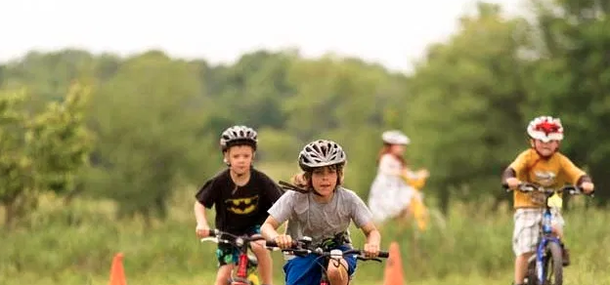
2020 season
WELCOME TO THE CLUB!!

Introduction

Surprisingly, MTB Kingston’s origins date back to the 9/11 terrorist attacks. The most popular trails in Kingston then were the Fort Henry trails, but these great trails were shut down for inexplicable security reasons. Sheila Gardner at J&J Cycle teamed up with Rob Sangers to open trails and the initial Glenburnie trail at The Farm was essentially the Home Loop.

Linking the trail access to a bike shop was not ideal, so in 2006 MTB Kingston was established. We have gone from 150 members up to over 1800 members over that time, making us one of the biggest, and least known clubs in town! We currently have an amazing youth race team, tons of volunteers, several race series, workshops, and trail building opportunities. Most importantly, we feel we have an amazing community of riders. Welcome.

Your current Board is:
Roisin Beck—communications and logistics (and good ideas)
Peter Dawson—communications and logistics (and good ideas)
Darryl Gillespie—Treasurer
Chris Frank—President
Rob Sangers—Operations and landowner #1
Frank Armstrong—Secretary

We are an IMBA affiliated club and our insurance is via IMBA. Our trails are mostly on private land with a section leased from the City. All riders must be members or have a day pass to ensure they have insurance to cover risk for our valued landowners. YOU MUST HAVE YOUR TAG ON at all times—see the signs at the trailhead for best way to affix it to your seat. If you need a second tag (because you can never have too many bikes) or lose yours, contact the Club via the website (mtbkingston.ca).

Riding at MTB Kingston

Trails and way finding
We have come a long way with our signage and are working on making it better. We do not post our maps online, but there is a big map at the kiosk outside the barn. We are working on connecting with an online service. We will send you a link to get to a video giving you a basic tour of the trails. We have trail markers and, new to the 2020 season, there will be You are Here signs at points along the network.

Trail ambassadors wear bright green/yellow jerseys and if you are uncertain, feel free to stop them on the trails to ask questions. Once you get familiar with the trails, consider becoming an ambassador!

Winter—you can ride all year, conditions permitting. We groom for fatbiking and also have a skate ski and classic trail loop too. There is at least one kid’s FB available to try via the Club.

Getting groceries at Glenburnie Store is great and super convenient on you way back from riding. Please support our local bike shops and partners like Trailhead.

There is a portable at the barn by the silo (on hold due to COVID). There is also a shower for warm days near the bike wash.

Rider Rules are found at http://www.mtbkingston.ca/club-rules/
Helmets are part of mountain bike culture and MUST be worn at all times.

Code of conduct
We value the sustainability of our trails and volunteers spend 100s of hours annually building and maintaining them. Please sign up for the Trail Report email option and if the weather is inclement, check the website for updates. The Demo Loop and the more technical southside trails are almost always open, but others are more sensitive to wet weather. The shoulder seasons are particularly tough and all trails may be closed at times. The kiosk has a sign on it that reflects trail status (but is not perfectly up to date given that we all have real jobs). Use common sense if unsure-—IF YOU ARE LEAVING A TRACK, YOU MUST TURN BACK is good motto.

Dogs are allowed but MUST be under control, especially if kids are around. DOGS ARE NOT ALLOWED ON COLLIN’S LAKE TRAIL. There are horses in fields to the east of the Home Loop near the end of the loop. Please do not take you dogs into this area, the final part of the Home Loop. Please go up at the parking area at the end of Demo loop.

Another aspects of the codes of conduct: please be civil on Facebook. Positive comments and support go further in building community than negative or demeaning comments. Thanks!

Please respect our neighbours and drive slowly down the driveway to the barn. We ask you not to park at the Pete’s Loop trailhead, but it is still OK to park at the Division Street end of Burbrook. To get to Collin’s please use the club driveway to get to Unity Road.

Safety
Mountain biking is great because there are no cars but does have inherent risks. We work hard to avoid risk coming from preventable issues. If you have any question or want to alert us to an issue, please contact us at contact@mtbk.ca rather than using Facebook.

At the barn kiosk there will be signs outlining the nature of different trails using the traditional green, blue, and black symbols. Trail markers will outline what to expect; for example, most of the Ridge trail is Blue, but there are some black sections so the trail is better for experienced riders or those willing to walk sections!

We have features that may be tricky, and more difficult ones will have an alternate route which will be signed. Please scout out features that are more challenging before riding them, just as you would skiing or snowboarding.

Communication
We are using our website and email for official notifications to members. There is a large Facebook group. Through our website, you can sign up for our official Trail Reports, which will arrive via email. The website has information on trail conditions and all events also.

Events
Our events really to try to focus on fun, especially our races. We have some riders who have raced at a national level and some who are doing their first ever race. You are really racing against yourself for the fun and challenge.

We would normally be having:
- orientation rides
- group workshops
- Club mid-summer festival
- Summer Classic, 6 Hour Relay, and Night Eliminator races
- The World Championship Wednesday night fall series (not really World Championship!)
- Weekly group rides
- Nature ride with a biologist
- Friday Night Lights group rides
- Youth race team events
- Kids group rides with bonfire

MTB Kingston also hosts a provincial race series event.

All these events are on hold obviously due to COVID.

Dates for all these events will be posted on the website if they happen.

How you can get involved
We are always looking for volunteers. This year we are introducing a volunteer coordinator. Trail days will be announced, and people interested in trail maintenance are most welcome.

Resources

MTB Kingston website http://www.mtbkingston.ca/
IMBA Canada https://imbacanada.com/

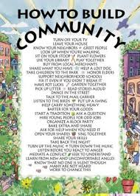
Our goal is to build community, great trails, and a group that loves mountain biking!

